EXPERIMENT 5 — STEP-WISE SOLUTION
Report Generation using Relational and Multidimensional Data on the Star Schema using Power BI

This guide follows the Experiment 5 practical instructions and continues from the Experiment 4 model. Menu names may vary slightly by Power BI Desktop version.

PART A: PREPARE AND VERIFY THE MODEL

Step 1: Open and save a separate copy
Open Power BI Desktop. Select File → Open report and choose the completed Experiment 4 PBIX file. Use File → Save as and save a separate copy named EXP 5 BI.pbix. Continue editing this copy so the Experiment 4 original remains unchanged.

Step 2: Verify relationships
- Select Model view from the left navigation.
- Find Fact_Sales and the four dimension tables: Dim_Customer, Dim_Product, Dim_Region, and Dim_Date.
- Confirm each required relationship connects Fact_Sales to the corresponding dimension table.
- Open each relationship and check that it is many-to-one (*:1), with the dimension table on the 1 side.
- Do not create duplicate relationships if the correct ones already exist.

Step 3: Verify Geo_Hierarchy and old pages
In the Data pane, expand Dim_Region and check that Geo_Hierarchy contains Region, State, and City in that order. Switch to Report view and open the Slice, Dice, and Drill pages from Experiment 4. Confirm that the visuals show real values and not blanks.

PART B: BUILD THE RELATIONAL REPORT

Step 4: Create a new page
Click the + icon beside the page tabs. Rename the new page Relational Report.

Step 5: Insert a Table visual
Click a blank part of the canvas, then select the Table visual from the Visualizations pane. Make sure you select Table, not Matrix.

Step 6: Add the six fields in order
- Expand Fact_Sales and drag Order ID into the table.
- Expand Dim_Customer and add Customer Name.
- Expand Dim_Product and add Product Name.
- Expand Dim_Region and add Region.
- From Fact_Sales, add Sales.
- From Fact_Sales, add Profit.
Check the final order: Order ID, Customer Name, Product Name, Region, Sales, Profit. If Sales and Profit display as Sum of Sales and Sum of Profit, that is normal for numeric fields in a table visual.

Step 7: Sort Sales from high to low
Select the table and click the Sales column header. If necessary, click again or use the visual's three-dot menu (…) → Sort by → Sales → Sort descending. The largest sales value should appear at the top.

Step 8: Apply Profit > 0
- Select the Table visual.
- Open the Filters pane.
- Under Filters on this visual, find Profit. If it is not listed, drag Profit into that section.
- Expand the Profit filter and choose Advanced filtering if needed.
- Set the condition to is greater than and enter 0.
- Click Apply filter if the button appears.
Check that every displayed row has positive profit. The filter should be a visual-level filter, not a report-wide filter unless the practical specifically asks for that.

Step 9: Export and note the observation
Right-click inside the table or use the visual's (…) menu and choose Export data. Choose Excel if available; otherwise save as CSV. Record the number of rows remaining after filtering and the customer and product in the first row. Use the actual report values.

PART C: BUILD THE MATRIX REPORT

Step 10: Create the page and Matrix
Click + and rename the page Matrix Report. Select a Matrix visual from Visualizations.

Step 11: Add the hierarchy and values
- Expand Dim_Region and drag Geo_Hierarchy into Rows. If the hierarchy does not appear as one item, add Region, State, and City in that order.
- Drag the existing Total Sales measure into Values.
- Drag the existing Total Profit measure into Values.
- Drag Quantity from Fact_Sales into Values and ensure its aggregation is Sum.
If Total Sales or Total Profit measures are missing, do not substitute a random field. Check whether equivalent measures already exist in Fact_Sales or the model before creating new ones.

Step 12: Test drill-down and drill-up
Use the matrix row expand controls or visual-header drill controls. Expand Region to State, then State to City. Use drill-up/collapse controls to return to State and Region. Choose the same state used on the Experiment 4 Drill page and compare the city-level values.
Observation: Record whether the figures match. If they differ, check the selected state, filters, measures, aggregation, and relationship paths before drawing a conclusion.

PART D: BUILD COMPARATIVE ANALYSIS

Step 13: Create the page
Click + and rename the page Comparative Analysis. You may copy the Sales by Category and Profit by Region charts from an earlier page, or recreate them on this page.

Step 14: Create Sales by Category
- Insert a bar or column chart.
- Drag Category from Dim_Product to the Axis.
- Drag Total Sales to Values.
- Set the title to Sales by Category.

Step 15: Create Profit by Region
- Insert a bar or column chart.
- Drag Region from Dim_Region to the Axis.
- Drag Total Profit to Values.
- Set the title to Profit by Region. Verify that the value is Profit, not Sales.

Step 16: Create Top 10 Customers by Sales
- Insert a horizontal bar chart.
- Drag Customer Name from Dim_Customer to the Axis and Total Sales to Values.
- In Filters on this visual, expand Customer Name and change the filter type to Top N.
- Choose Top and enter 10.
- Drag Total Sales into the By value field.
- Click Apply filter.
- Sort the chart by Total Sales in descending order and title it Top 10 Customers by Sales.

Step 17: Create Sales Trend by Year
- Insert a Line chart.
- Drag Year from Dim_Date to the X-axis. Use the Year field, not the full date hierarchy, if a separate Year field exists.
- Drag Total Sales to the Y-axis or Values.
- Set the title to Sales Trend by Year.

Step 18: Write comparative observations
Review the four visuals together. Note the category with the highest sales, the region with the highest profit, the customers ranked in the Top 10, and whether yearly sales rise or fall. Do not state a winner or trend unless it is visible in your report.

PART E: CREATE THE INTERACTIVE DASHBOARD

Step 19: Create the Dashboard page
Click + and rename the page Dashboard. Arrange the page with KPI cards and slicers at the top and charts below.

Step 20: Add KPI cards
- Insert a Card visual and add Total Sales. Enable the title and label it Total Sales.
- Insert a second Card and add Total Profit. Label it Total Profit.
- Insert a third Card and add Total Orders. Use the existing Total Orders measure if available.
If a Total Orders measure does not exist and Order ID uniquely identifies an order, a possible DAX measure is: Total Orders = DISTINCTCOUNT(Fact_Sales[Order ID]). Use the exact table and column names in your model.

Step 21: Add the three slicers
- Insert a Slicer and add Region from Dim_Region.
- Insert another Slicer and add Category from Dim_Product.
- Insert a third Slicer and add Year from Dim_Date.
Set slicers to Dropdown if space is limited. Copy the relevant charts from Comparative Analysis and paste them onto the Dashboard page.

Step 22: Test slicer interactions
- Select one Region in the Region slicer and check the cards and charts.
- Select a Category and confirm the appropriate values change.
- Select a Year and verify the relevant visuals respond.
- Clear slicer selections and confirm the report returns to its unfiltered state.
- If a visual does not respond, select the slicer → Format → Edit interactions and set the relevant visual to Filter instead of None.

PART F: FINAL REVIEW AND SUBMISSION
- Save the PBIX frequently with Ctrl+S.
- Keep the original Experiment 4 file unchanged.
- Check the page names: Relational Report, Matrix Report, Comparative Analysis, and Dashboard.
- Confirm all fields and titles are correct.
- Verify the Profit > 0 filter and export the table.
- Test the geographic hierarchy and compare it with Experiment 4.
- Test each dashboard slicer against the visuals.
- Take screenshots of each finished page if your teacher requires evidence.
- Complete the written observations with actual values from Power BI.

Sample final interpretation
A regional manager would use the Dashboard to review overall performance through KPI cards, charts, and filters for Region, Category, and Year. The Relational Report is used to inspect individual transactions, customers, products, sales amounts, and profits. The Dashboard supports high-level decisions, while the Relational Report supports detailed investigation.

Troubleshooting notes
- If a field is missing, expand the correct table in the Data pane and verify the exact field name.
- If the table displays blank customer or product names, check the relationships between Fact_Sales and the dimension tables.
- If the Top N chart shows more than ten customers, confirm that Total Sales is in By value and click Apply filter.
- If the matrix does not expand, ensure Geo_Hierarchy is a hierarchy and use the visual's expand/drill controls.
- If slicers do not affect visuals, inspect Edit interactions and model relationships.
- If values differ from Experiment 4, compare filter selections, aggregation settings, and measure definitions.

Visual Reference Appendix
These diagrams are illustrative guides to the intended report layout. They are not actual Power BI screenshots or measured results. Use them to compare the arrangement of your own visuals.
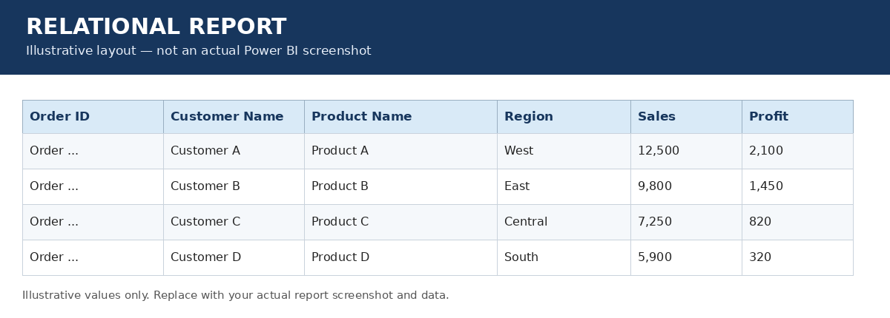
Figure B1. Relational Report table layout.
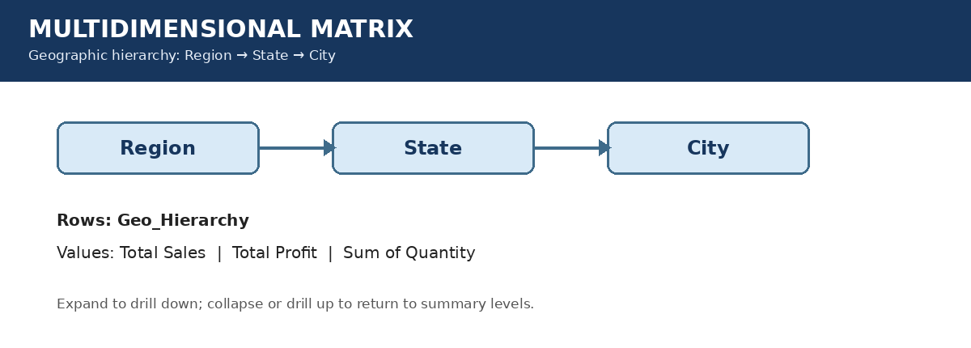
Figure B2. Matrix hierarchy: Region → State → City.
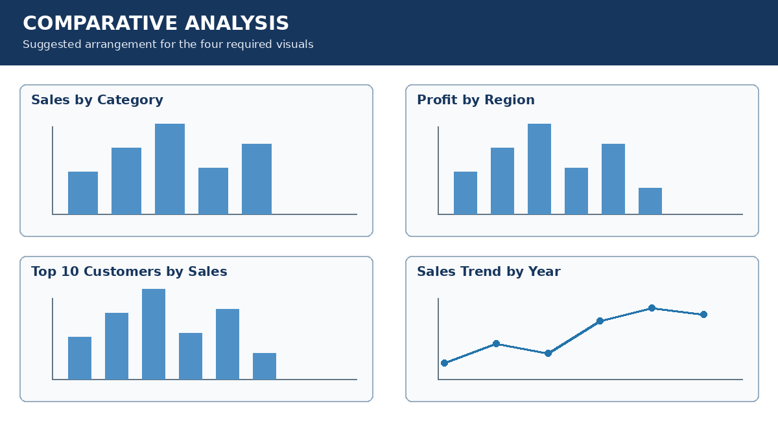
Figure B3. Comparative Analysis layout with four visuals.
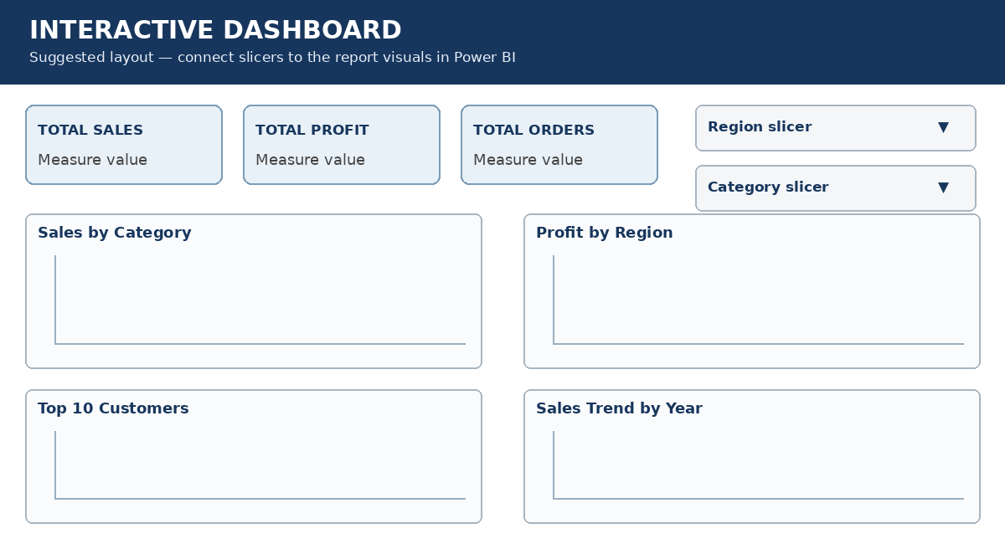
Figure B4. Dashboard layout with three KPI cards, slicers, and charts.

